**EXPT-7 DATE- 15-04-2021**

**AIM -> C - Program to Find First and Follow of a Grammar.**

**THEORY -**

1. The first and follow sets are used in compiler designing process. The first set is used in LL parsers which are top – down parsers that read or interpret from left to right.
2. The follow set is used in LR parsers which are bottom-up parsers that read or interpret from right to left.
3. The LL parsers use leftmost derivations whereas the LR parsers use rightmost derivations. A predictive parser is constructed using first and follow sets that are associated with Grammar G.

PROGRAM = FIRSTOF().c

INPUT - **E🡪TD**

**D 🡪+TD**

**D=$**

**T=FS**

**S=*FS**

**S=$**

**F=(E)**

**F=a OUTPUT --🡪**

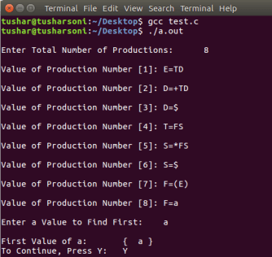

-----------------------------------------------END----------------------------------------------------

FOLLOWOF().c

OUTPUT -

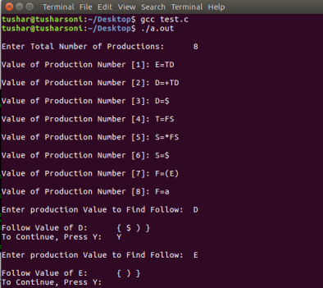

--------------------------------------------END-----------------------------------------------------------------